

Greetings from Military Pathways (www.facebook.com/MilitaryPathways ) and @MilitaryPathway (www.Twitter.com/MilitaryPathway )! You can use the following posts to direct your Facebook and Twitter likers and followers to helpful mental health resources during National Depression Screening Day (Oct. 6th), throughout the month of October and throughout the year.

Not all wounds happen on the battlefield. Some are not even physical. But all wounds need attention. National Depression Screening Day educates military personnel and their families about signs & symptoms of depression, PTSD, generalized anxiety disorder and bipolar disorder through anonymous online self-assessments. The primary goals of the program are to reduce stigma & increase help-seeking. To find out more visit: http:///www.MilitaryPathways.org.

A 2010 New England Journal of Medicine study found that among women whose husbands were deployed, 36.6% had at least one mental health diagnosis, as compared with 30.5% of women whose husbands were not deployed. If you’re a military spouse who is suffering visit: http://www.MindBodyStrength.org and take the first step toward healing.
- “When a service member deploys, the entire family deploys," says Air Force Maj. April Cunningham, a Pentagon spokeswoman. Find out what families should know when it comes to war-zone related stress reactions http://ow.ly/6yN3f

Posttraumatic stress disorder (PTSD) can be caused by a single traumatic event such as an attack or assault, serious accident or the death of a loved one. But, if left untreated, PTSD can steal joy and happiness from your life. Don’t let PTSD have that power over you. Visit http://www.MindBodyStrength.org and take the first step toward getting help.
- Think exercise is all about toned abs? Think again. Not only does regular exercise improve physical problems such as high cholesterol, diabetes and high blood pressure, it also boosts higher-level thinking and combats depression and anxiety. Check out these exercise tips from the Video Doctor http://ow.ly/6yMFi
- An August study done by the University of Texas Southwestern Medical Center and published in the Journal of Clinical Psychiatry found that exercise can be as effective as a second medication for as many as half of depressed patients whose condition has not been cured by a single antidepressant medication. Visit http://www.MindBodyStrength.org and make the connection today!
- The SOS high school program is the only school-based suicide prevention program listed on the Substance Abuse and Mental Health Services Administration’s National Registry of Evidence-based Programs and Practices that addresses suicide risk and depression, while reducing suicide attempts. In a randomized controlled study, the SOS program showed a reduction in self-reported suicide attempts by 40 percent (BMC Public Health, July 2007). Check out the video trailer for Military Pathways® new SOS Friends for Life: Preventing Teen Suicide DVD: http://ow.ly/6cROd

  - Is self-injury a suicidal act? Go to http://ow.ly/6cU0s & get the 411 on self-injury and teen suicide prevention. #NDSD
  - Think men don’t cry? Visit: http://ow.ly/6zMwc and get the facts on men and depression. #NDSD
  - 4% of preschoolers are clinically depressed. Download a feelings journal http://ow.ly/6zNQX & start tracking your child’s emotions #NDSD
  - A little sweat can keep the blues away. Check out the Video Doctors tips on working exercise into your life. http://ow.ly/6zOp2
  - Women are 70% more likely than men to be depressed during their lifetime. Visit http://ow.ly/6zMPO & find out why women get the blues. #NDSD
  - It takes a different kind of courage to heal a hidden wound http://ow.ly/6yNyz PLS RT #NDSD
  - Get your FREE SAFE-T Suicide Assessment Five Step Evaluation & Triage Card! http://ow.ly/6zWdr PLS RT #NDSD
  - War, Wives and a Near Suicide http://ow.ly/6zWsJ #NDSD
  - Check out the story of a military teen featured in the new SOS Friends for Life: Preventing Teen Suicide DVD: http://ow.ly/6zWMR PLS RT
  - Healthy Body, Healthy Mind – Visit : http://www.MindBodyStrength.org and make the connection PLS RT #NDSD

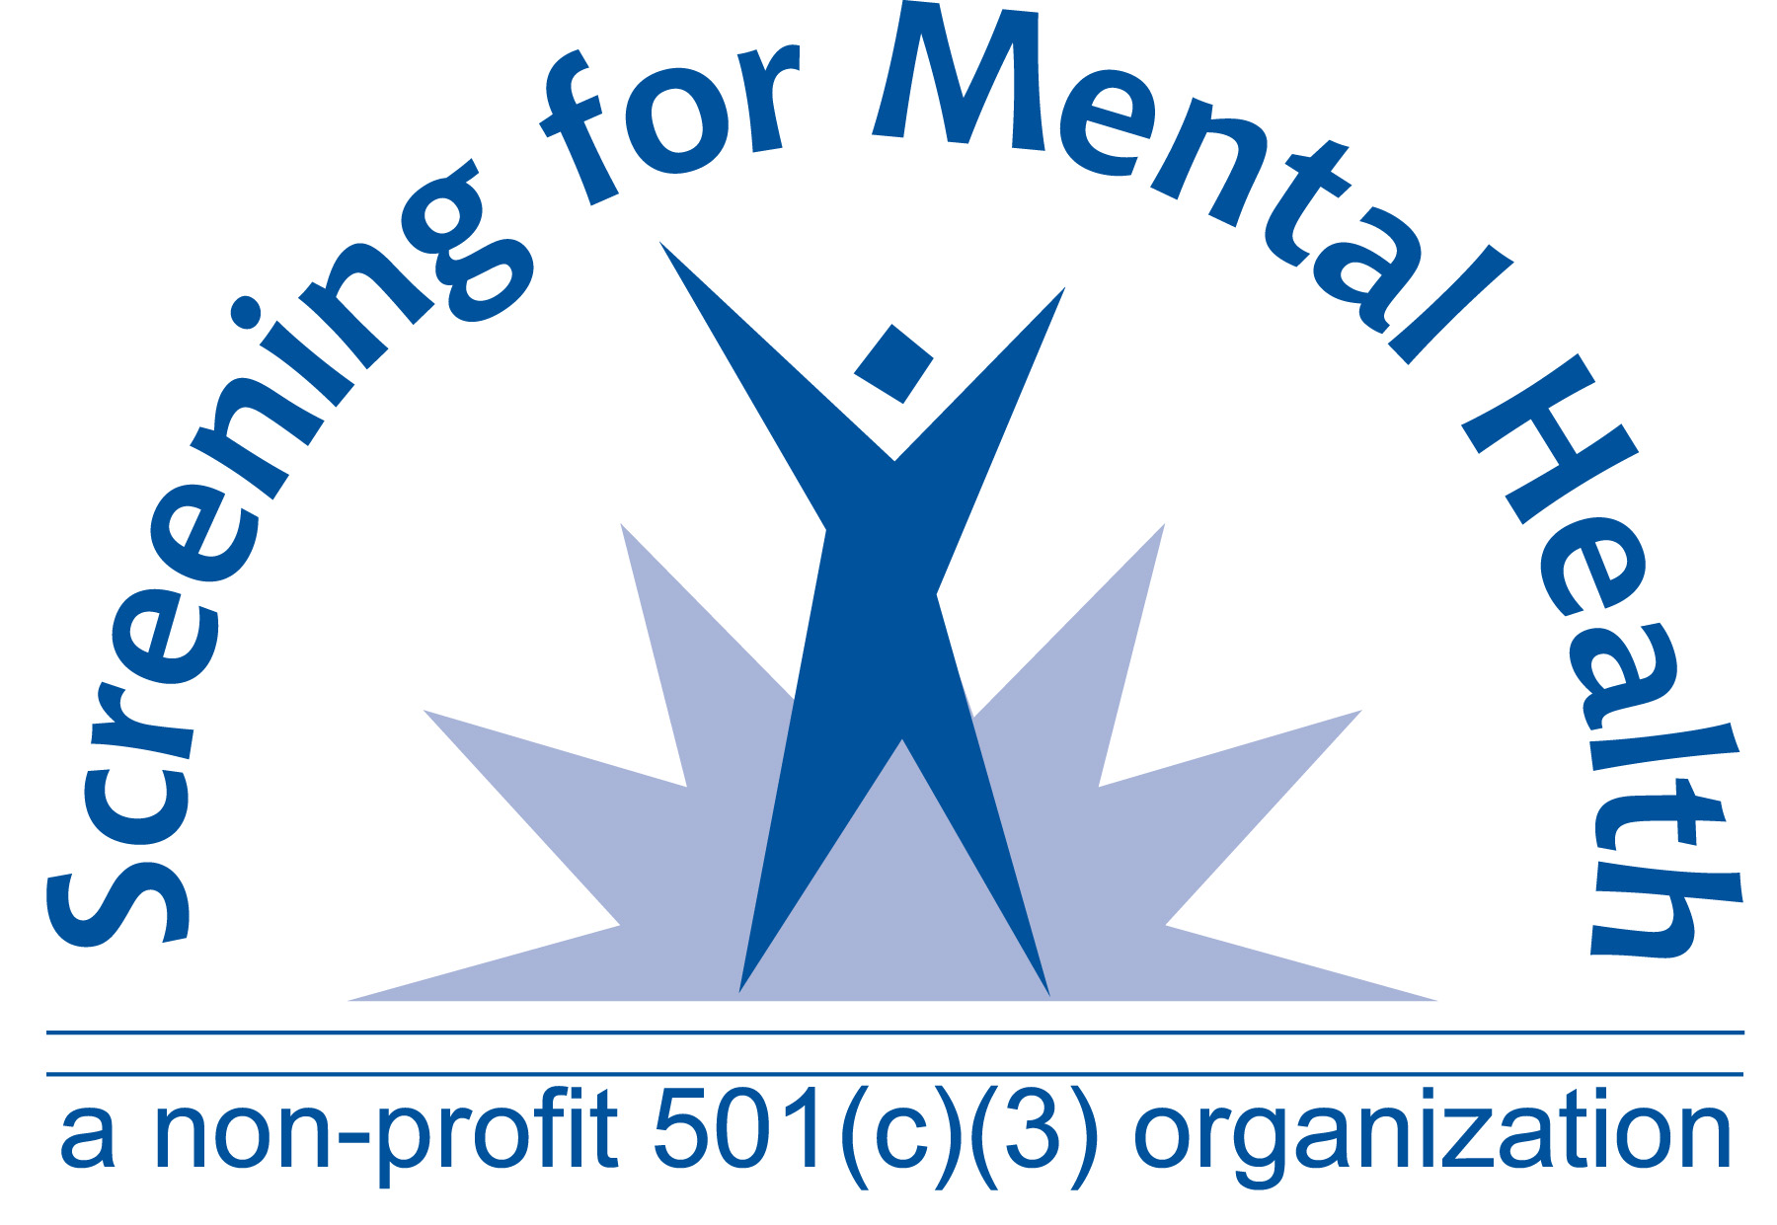
Funded by Force Health Protection and Readiness, Office of the Assistant Secretary of Defense, Health Affairs
Screening for Mental Health, Inc.| One Washington Street, Suite 304, Wellesley Hills, MA 02481
Phone: 781-239-0071 | Fax: 781-431-7447| Email: military@MentalHealthScreening.org | www.MilitaryPathways.org

